V. Kostić,Kulurne veze između jugoslovenskih zemalja i Engleske do 1700. godine, Beograd, SANU, 1972.

South Slavic Writers and Scholars in England in the 16th and 17th century

Marin Getaldić (Ghetaldi)

Numerous businessmen, merchants and seamen came from the Republic of Dubrovnik to England in the 16th century. One of them was Nikola Nalješković (de Nale), who may have known the poet Nicholas Grimauld and who certainly knew Sir Thomas Gresham. The most important Dubrovnik merchant in London in the second half of the 16th century was Nikola Gučetić (de Gozzi), who knew personally at least two English men of letters – John Florio and Sir Walter Ralegh. But the most famous man who came to England from Dubrovnik in this period was the mathematician Marin Getaldić. It has been known for a long time that Getaldić travelled to England at the end of the 16th century and spent two years there, but it was not clear why he visited England and what he did there. The newly discovered evidence shows that he accompanied Marin Gučetić, the nephew and heir of Nikola Gučetić, who came to London in 1595 at the news of his uncle’s death. Getaldić stayed in London about two years, probably helping Marin to settle the affairs of old Nikola. After that he seems to have gone to Antwerp as Marin‘s agent. In Flanders he met Michele Coignet, whose influence proved of great importance for the future work of the Dubrovnik scholar. There is no evidence to support the hypothesis that Getaldić met some English mathematicians and astronomers during his stay in England, but it is known that he was on friendly terms with some British scholars whom he got to know later in France and Italy.

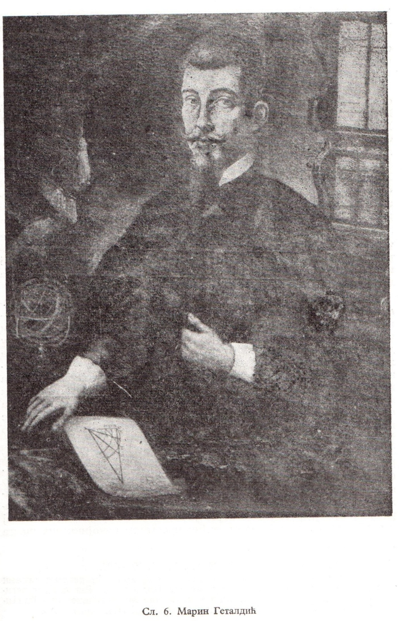
Marin Getaldić

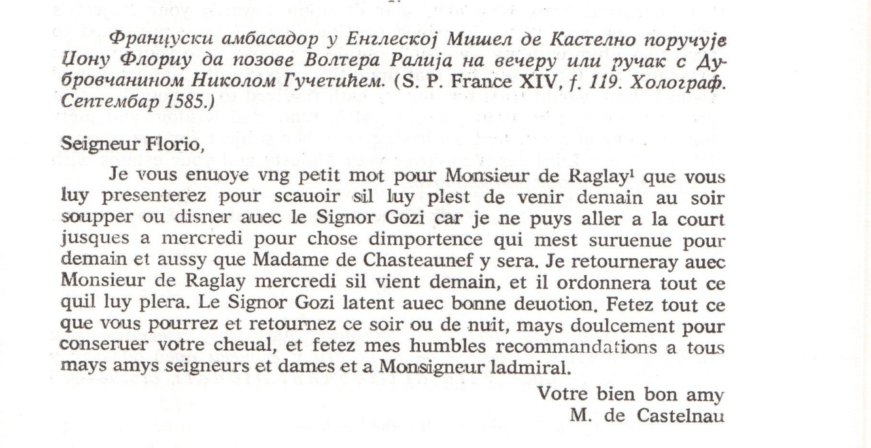

Ivan Franjo Bjundović (Giovanni Francesco Biondi)

I.F. Bjundović, poet, novelist, historian, diplomat and courtier of King James I, was born on the island of Hvar (Lesina) in 1573. He studied law and worked for some time as a lawyer in his native town. In 1606 he went to Venice on business and shortly afterwards was appointed secretary to Pietro Priuli, the Venetian Ambassador to France. In Paris Bjundović met Sir George Carew, the English Ambassador, and some of the French protestant leaders. When he returned to Venice he brought with him their confidential references to Sir Henry Wotton, the English Ambassador to the Venetian Republic. In the following months Bjundović played an active part in the movement for religious reform in the Venetian Republic directed by Wotton and Paolo Sarpi. It was as Wotton's and Sarpi's confidential agent that he travelled to England in 1609. He was well received there, but his hopes for a permanent position in England were not fulfilled because he did not make a good impression on Salisbury. Thus he was sent back to Venice as a salaried agent attached to the English Embassy. [...] For some time he did intelligence work for Carleton, but as his pay from England was practically discontinued he decided to travel to London again and apply personally to the King for a more constant income. He succeeded in this beyond his expectation and secured a permanent annual pension of 200 pounds.
In 1614 Bjundović went to the Hague. In 1616 he was sent to Savoy and returned thence as the agent for Savoy in England – a diplomatic post of very slight importance, since the relations between the English King and the Duke of Savoy were virtually broken during the period that he held this office. Nevertheless, it was in this capacity that Bjundović achieved what he regarded as his greatest diplomatic success – the reconciliation of England and France in 1619.
After this Bjundović disappears from the diplomatic scene and his later life is difficult to trace. In 1622 he was knighted at Windsor, and some time later he married the sister of the court physician Dr. Theodore Mayerne. After King James’s death and the accession of Charles I he lost his position at court and his pension was paid very irregularly. After the outbreak of the Civil War Bjundović, long known for his attachment to the ideals of absolute monarchy, sought a more secure climate. He left England on Dr. Mayerne’s estate at Aubonne in Switzerland, where he died in 1645.
After his voluntary or involuntary retirement from active diplomatic service in 1619 or 1620, Bjundović devoted his leisure to writing. He wrote three novels (Eromena, La donzella desterrada, Il Coralbo) and a history of the Wars of Roses (L’istoria delle guerre civili d’Inghilterra). All these works, written originally in Italian, were translated into the English language.
The importance of Bjundović’s novels in the context of Italian literature was defined as early as the 17th century by Tommaso Stigliani, who said that Bjundović
had introduced a new prose style in Italy. Modern Italian scholars accept this judgment. What has remained unexplored is the English component of these novels. The search for a possible model has been facilitated by the fact that Bjundović, as he himself says, admired Sir Philip Sidney’s Arcadia and even made an abortive attempt to translate it. The stylistic and structural devices of his novels are similar to those of Sidney’s great work, and there can be little doubt that the reading of Arcadia helped Bjundović to play the role of a stylistic innovator in Italian literature.
Bjundović’s more academically minded readers preferred, however, his History to his novels – a judgment which the modern reader, who has lost the taste for the endlessly complex plots and rich ornamentation of baroque romances, is apt to endorse. As can be expected, Bjundović’s history is not very original – it does not contain new facts unknown to previous historians. He takes his material from a number of English, French and Scottish writers. […] Bjundović accepts the current, official conception of the Wars of the Roses, but apart from that he shows great independence in the interpretation of the past. His attitude is detached and refreshingly free from national bias. Besides, his history makes good reading – complex historical events are presented with lucidity and considerable narrative skill.

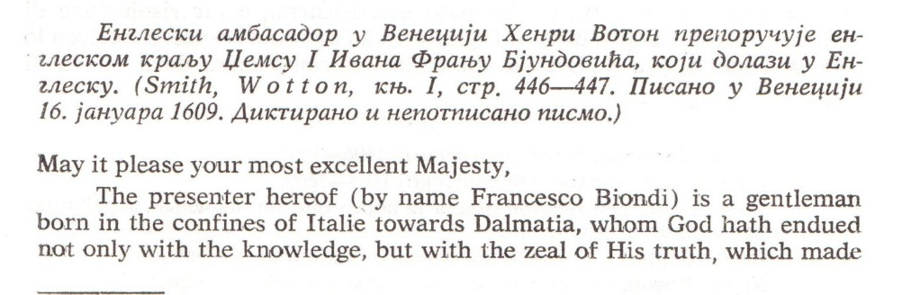
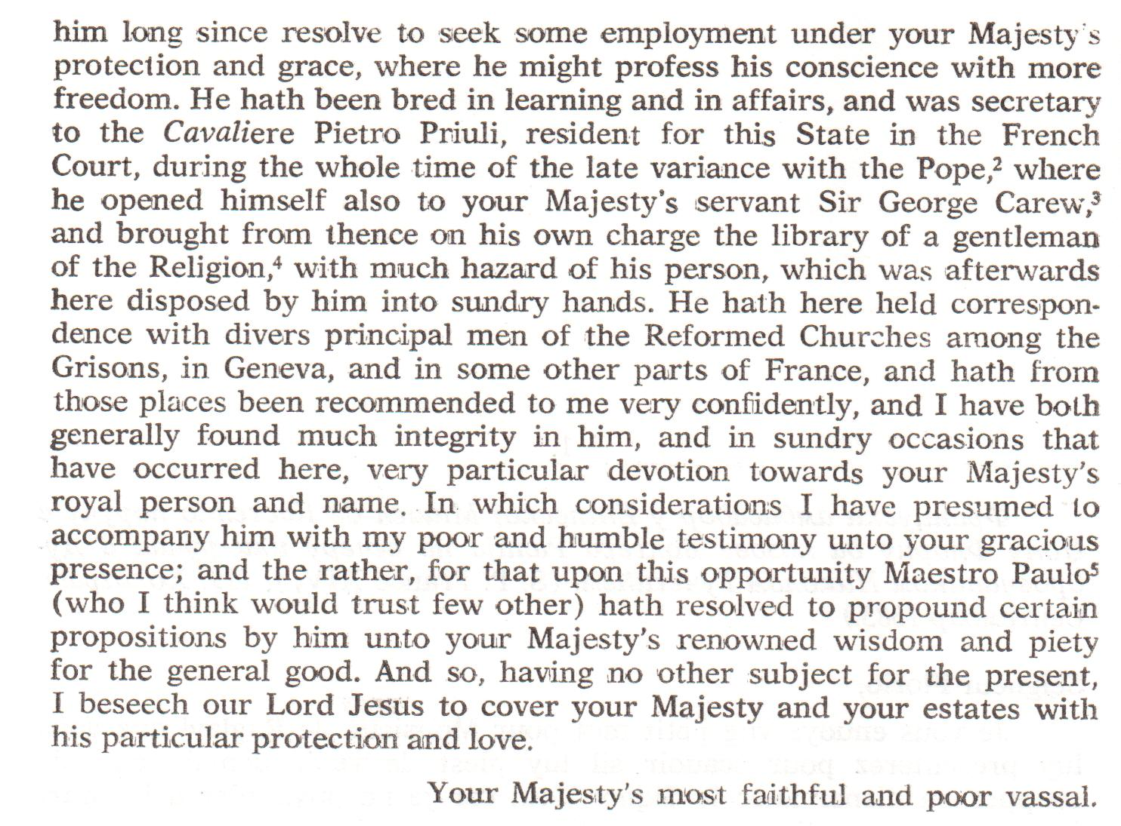
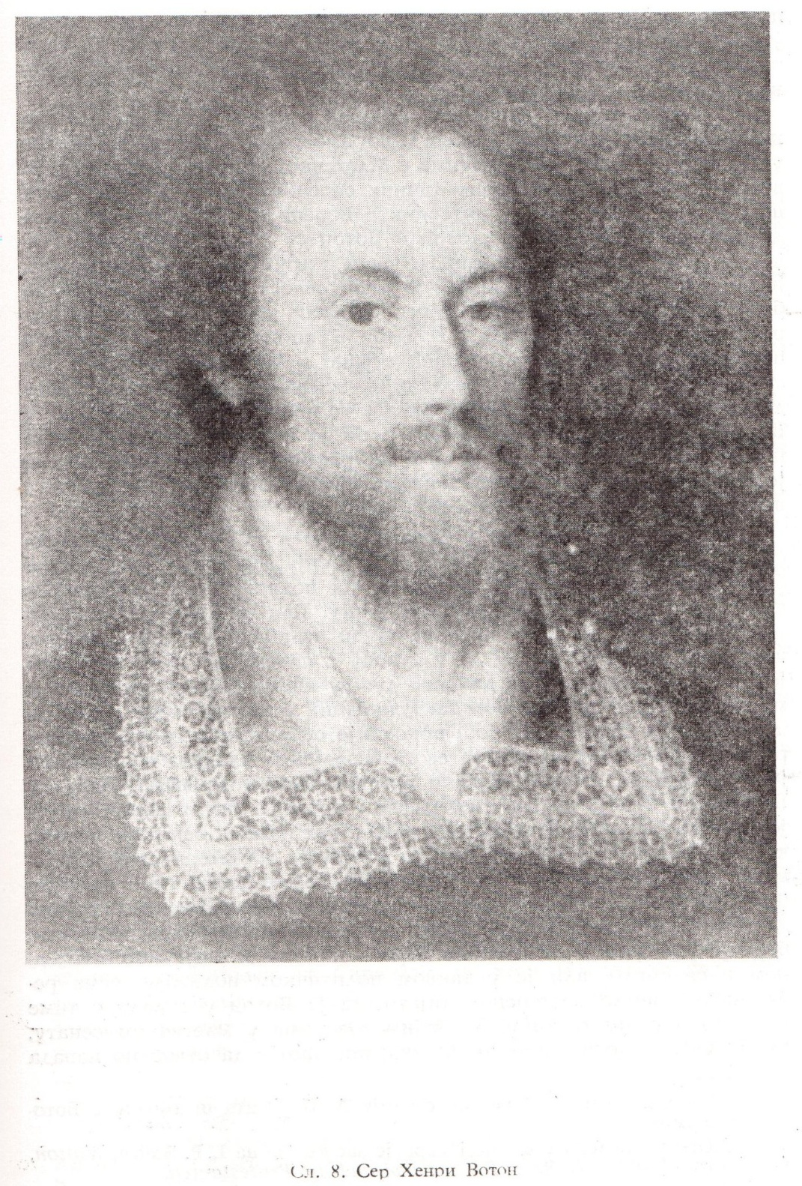
Henry Wotton

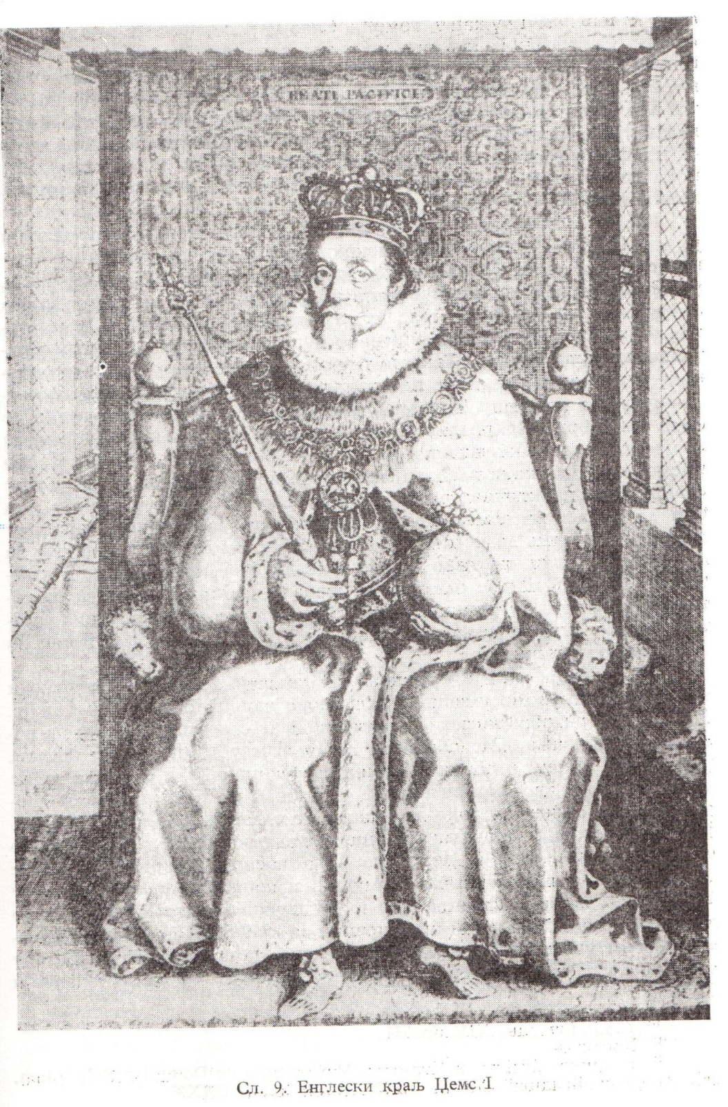
James I

Marcantun de Dominis

Dominis was born on the island of Rab (Arbe) in the Adriatic and studied theology at Loretto and Verona. Later, he taught with great success at Verona. Padua and Brescia. In 1596 he became the Bishop of Senj (Segna) and in 1602 he obtained the Archbishopric of Split (Spalato). During the Interdict he sided with Venice and started writing a book against the papal authority. Rome learnt of it, became hostile and tried to get hold of him. Dominis, who was aware of the danger, got into contact with the English Ambassador to Venice in 1614 asking him to prepare a refuge for him in England in case of need. King James was glad to take into his protection the distinguished apostate and replied to Carleton that the Archbishop would be welcome. Two years later Dominis came to England and was received with extraordinary enthusiasm.
During the first months of his stay in England Dominis lived at Lambeth Palace, the residence of the Archbishop of Canterbury. He spent most of his time preparing for the press his magnum opus, the famous and influential De Republica Ecclesiastica, the manuscript of which he brought with him from Split. Towards the end of 1617 the first volume of De Republica Ecclesiastica was published. In England and other protestant countries it was acclaimed as a work of great importance and profound learning, and in Roman Catholic parts of the world it provoked a flood of polemical literature. During these months Dominis was an object of constant public attention. He was invited to take part in the ceremony of the laying of hands on new English Bishops, he began to preach regularly and with great success in the church of Italian colony in London (Mercer’s Chapel) , and was a frequent and revered visitor to the court. But he was not fully satisfied with his position in England; he had no income of his own and was dependent on the hospitality of the Archbishop of Canterbury.
The situation improved at the beginning of 1618. In March Dominis was given the mastership of the Savoy, which became his residence. Two months later he obtained – not without some difficulty – the Deanery of Windsor. Thus he was finally in possession of independent livings enabling him to live quite comfortably. He continued his studies and published a short polemical work The Rocks of Christian Shipwreck. He also prepared for the press Sarpi’s History of the Council of Trent, although he did not bring the manuscript of this work to England, as is sometimes asserted.
In the later years of Dominis’s stay in England the relations between him and the English deteriorated. Both sides seem to have been responsible for this. As time passed, Dominis showed increasing interest in worldly goods, and some people accused him of avarice and inordinate ambition. On the other hand, Dominis must have felt that he was unjustly neglected after the splendid welcome extended to him at his arrival. Some of the honours accorded to him in public ceremonies were gradually forgotten or deliberately omitted, and many promises given to him remained unfulfilled. The history of the relations between Dominis and his English hosts is a record of a series of mutual disappointments.
The pope learnt of Dominis’s disaffection and, anxious to end the scandal of his apostasy, asked the Spanish Ambassador to England Gondomar to treat with the Archbishop for his return to the Roman Catholic Church. By October 1621 the negotiations, conducted through confidential agents, were nearly completed, and Dominis had made the decision to return to Rome. In January 1622 he wrote to King James asking his permission to leave England.
The King was extremely angry and prohibited Dominis access to the court until he decided what to do with him. During the following months Dominis was subjected to repeated written and oral questionings. In April 1622 he was finally permitted to leave (or rather banished), but not before written evidence sufficient to damn him in the eyes of the Inquisition was extracted from him. Dominis went to Rome, where he published a recantation, and was soon afterwards imprisoned. He died in prison in September 1624, while the verdict in his trial by the Inquisition was still pending. He was posthumously declared guilty of heresy, and his corpse was publicly burnt on the Campo di Fiori in Rome.

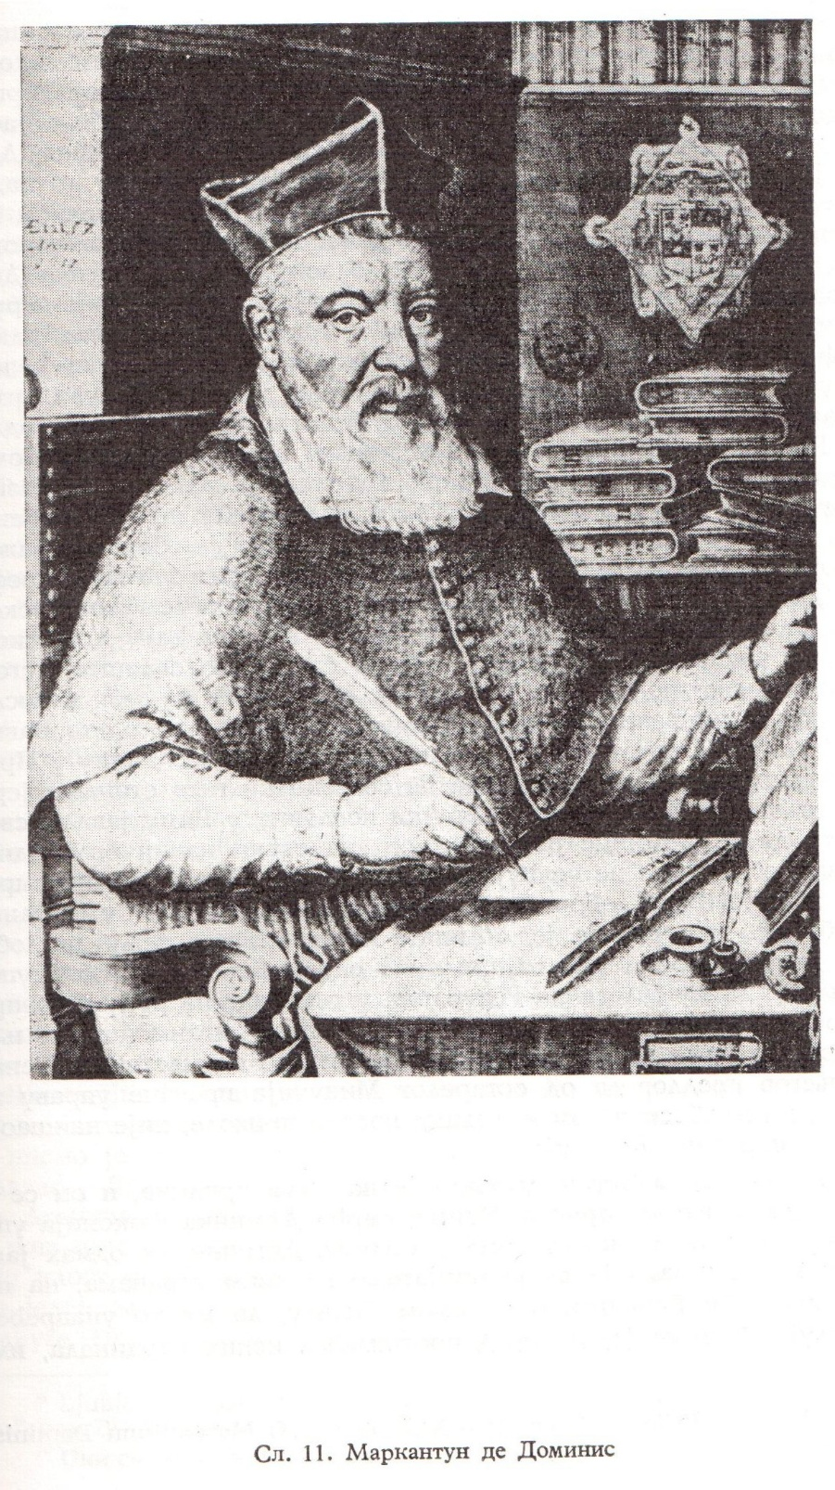
Marcantun de Dominis

